* P. Ram Charan
* Batch -125
* Phone number :6304335587
* Create s3 bucket in Virginia Region

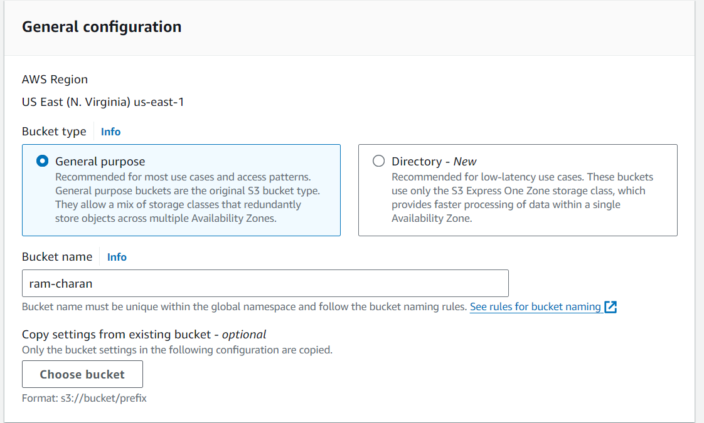

* Upload a folder

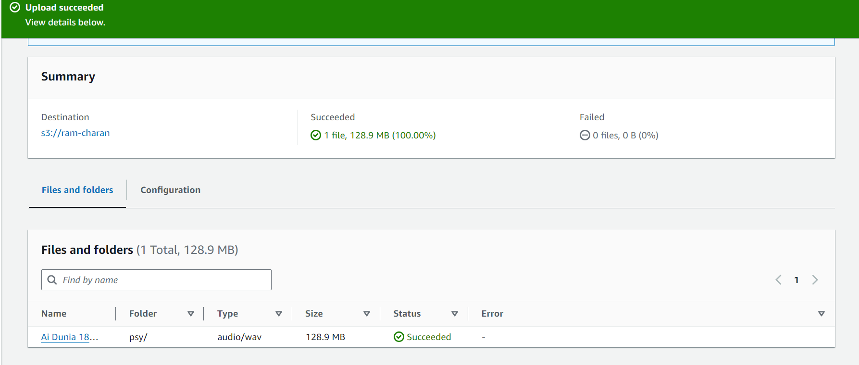

* Enable Bucket versioning

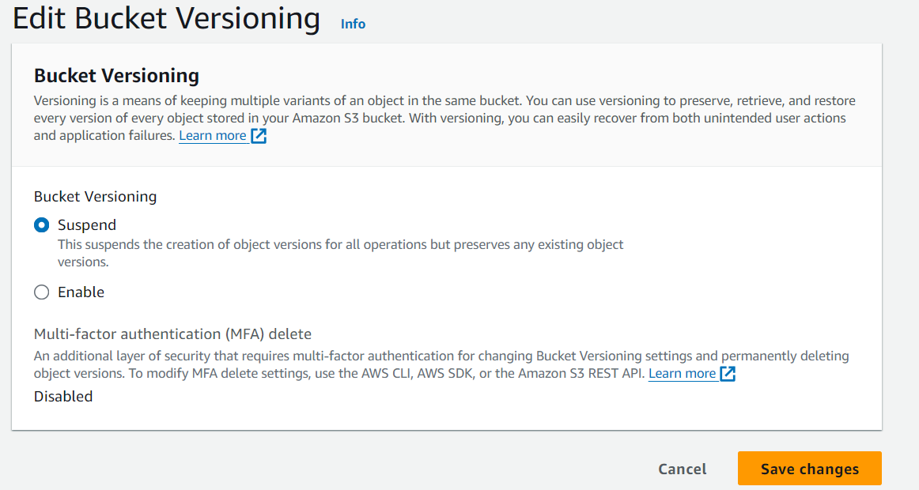

* New version ID by the editing

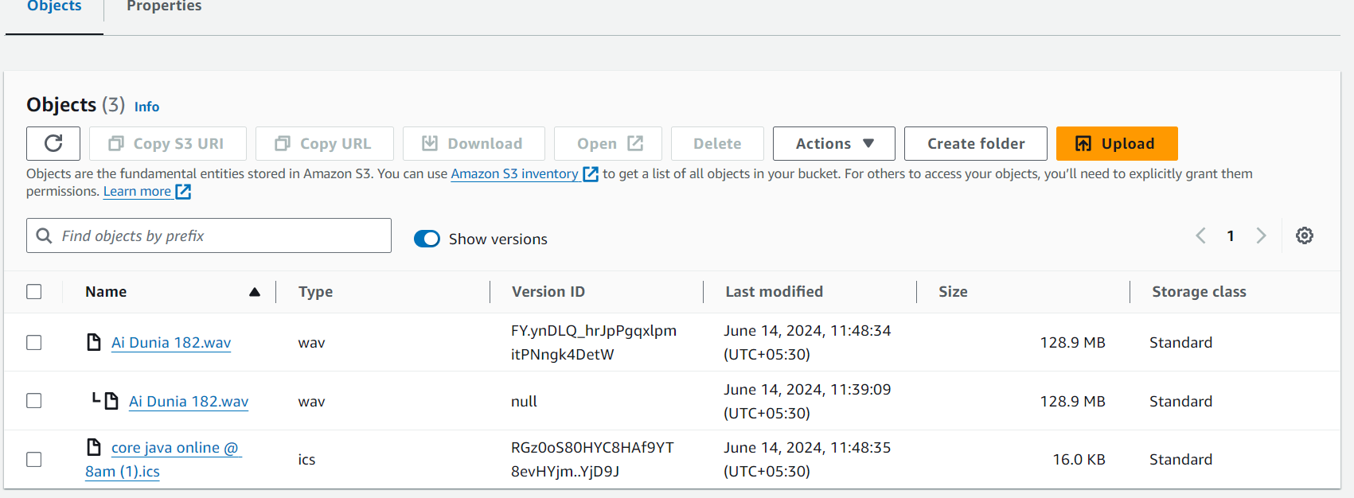

* Enable transfer acceleration use to transfer data fast b/w to regions

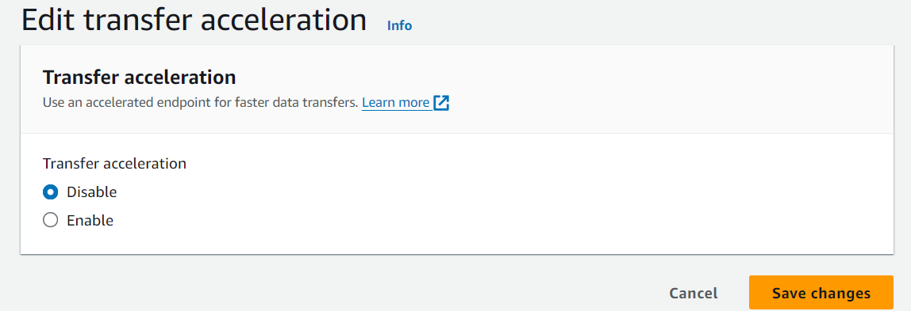

* Cross region replication
* Create a bucket in another region that is Ohio

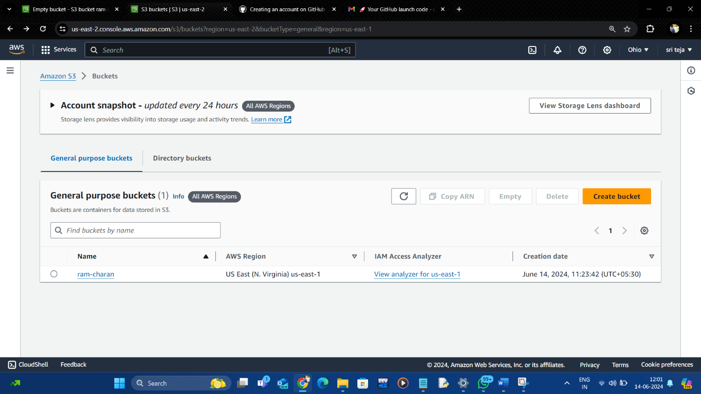

* Create a replication rule from source bucket

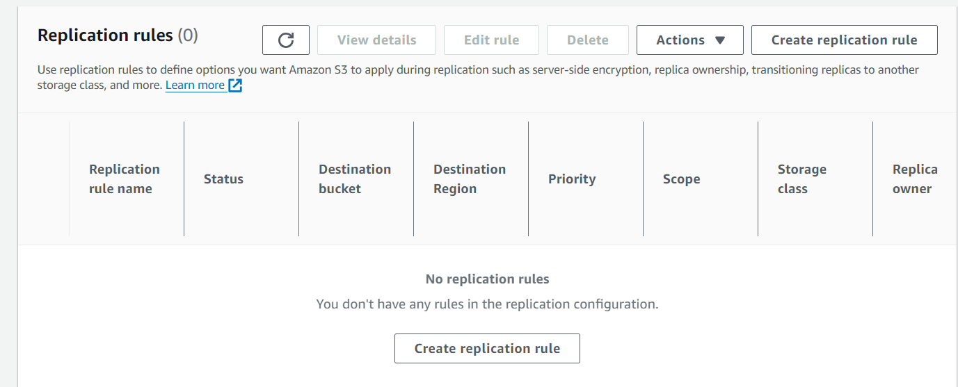

* Source bucket

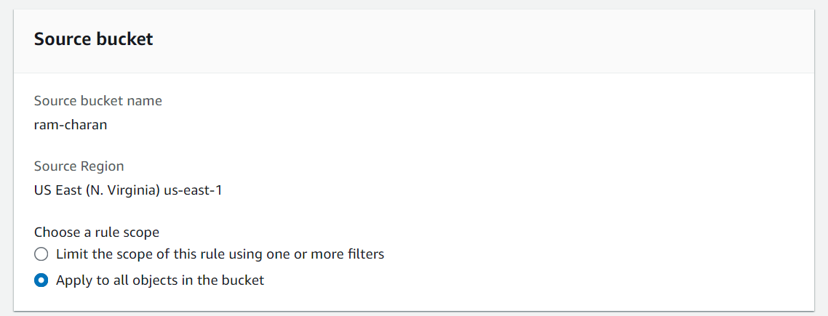

* Set the destination bucket to replicate

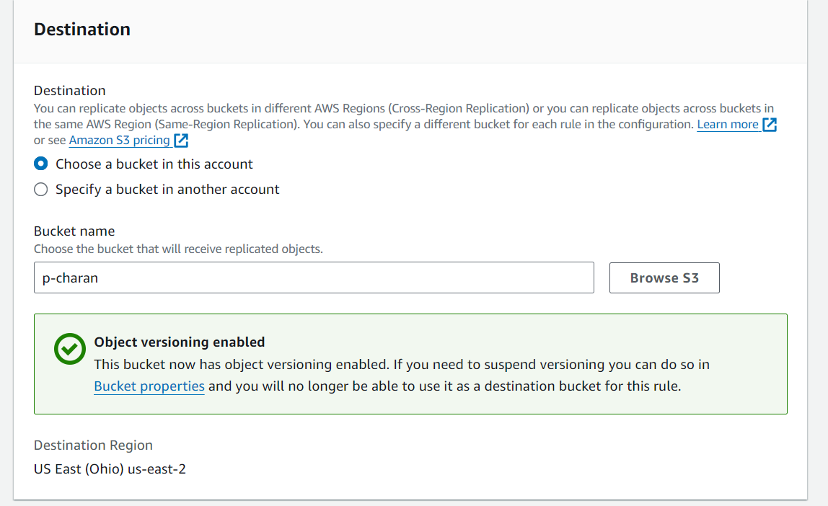

* Create new role & save the bucket rules

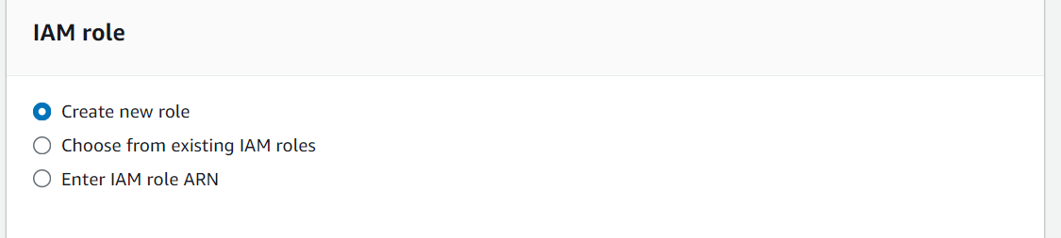

* Completion report destination & save

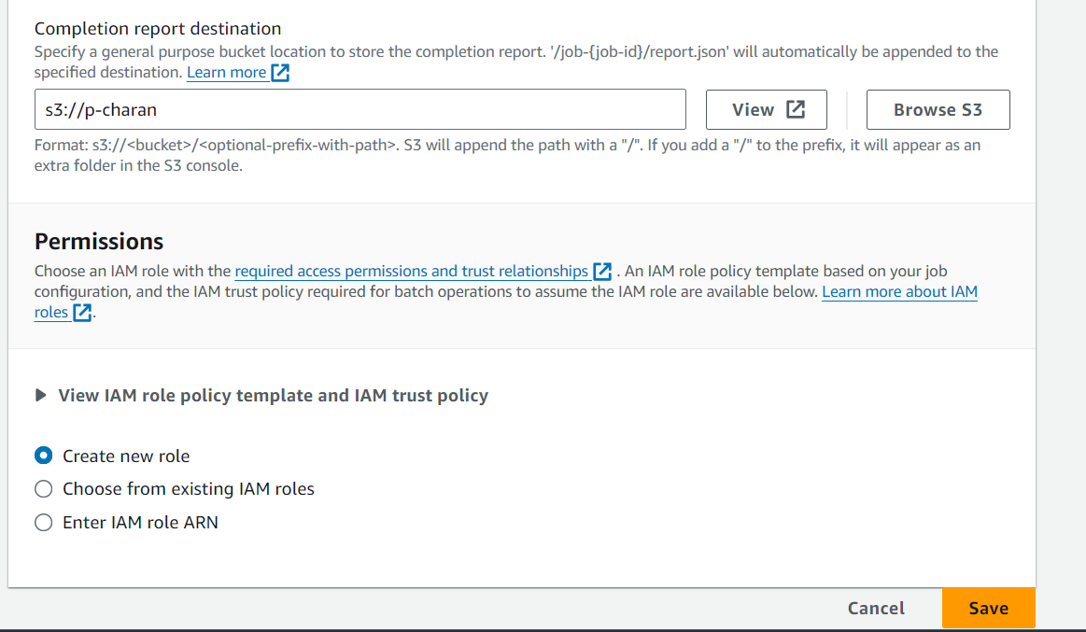

* Buckets

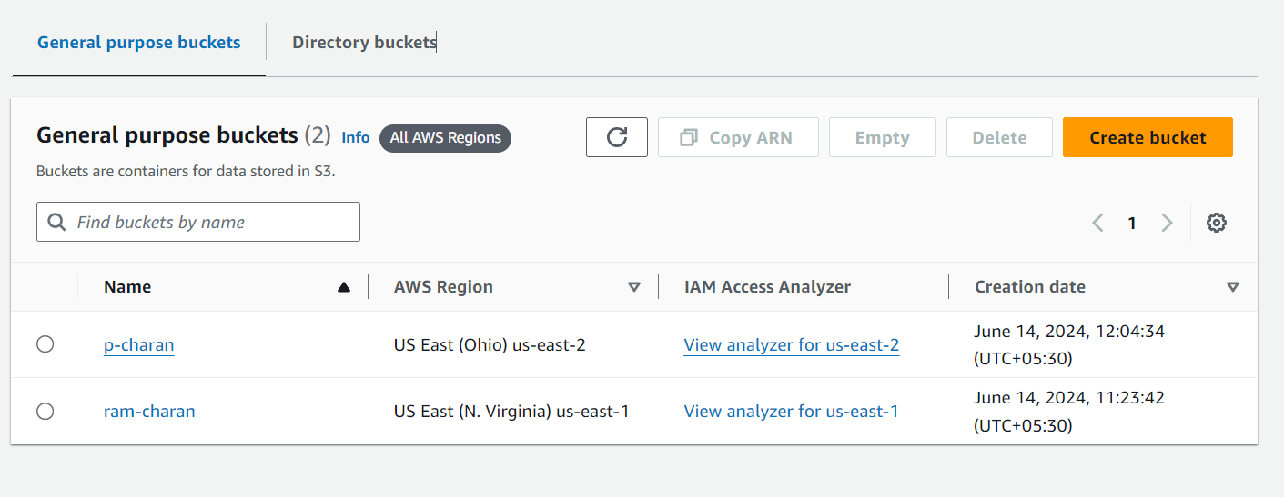

* ram-charan is the source bucket
* p-charan is the destination bucket

\*\*\*\*\*\*\*\*\*\*\*\*\*\*\*\*\*\*

* Source bucket data(ram-charan)

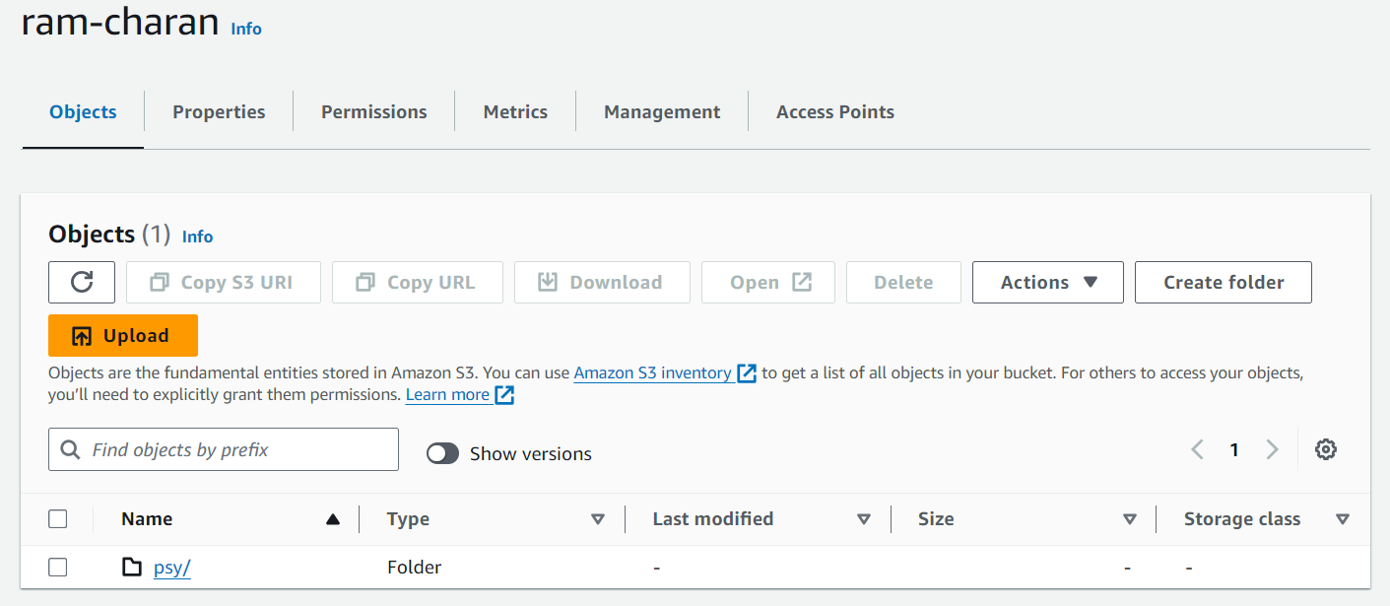

* Destination bucket data(p-charan)